**Year 8 Science**

**2022**

**Topic Test: (M)**

**Particle Model, Kinetic Theory & Density**

**Name: _________________________ Marks: 28**

**Teacher: _______________________**



**Materials Required:**

* **Blue/black ballpoint pen**
* **Pencil**
* **Ruler**
* **Eraser**
* **Calculator**

|  |  |  |
| --- | --- | --- |
| **Section 1**  **(6)** | **Section 2**  **(22)** | **Total**  **(28)** |
|  |  |  |

**Section 1: Multiple Choice [6 Marks]**

**Circle the letter of the most correct answer for each of the statements or questions below.**

1. The Kinetic Theory of Matter states that all matter is made up of

1. stationary particles
2. substances having no regular properties
3. gases and liquids which collide
4. small moving particles

2. To be called “matter”, a substance must have

1. shape and volume
2. solid, liquid and gaseous forms
3. mass and volume
4. chemical properties

3. When a liquid is poured from one container into a different container, which of the following will happen?

1. Its volume changes
2. Its shape changes
3. Its shape and volume changes
4. Its shape and volume does not change
5. The recycling of aluminium can be considered as a series of physical changes as shown by the flow diagram below:

What are the states that aluminium exists in, in this diagram above?

1. Only solid
2. Solid and liquid
3. Solid and gas
4. Gas and liquid
5. When heat is added to a substance, which of the following occurs?
6. Particles become more attracted
7. Particles get larger
8. Particles get smaller
9. Particles move faster
10. An object will float on top of a liquid if it is less dense than the liquid and sinks if it is more dense than the liquid. Four identical balls are dropped in four different liquids shown below. Which liquid is most dense?

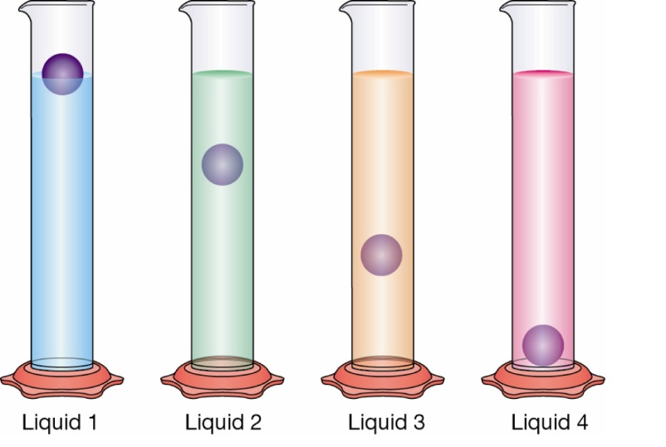

1. liquid 1
2. liquid 2
3. liquid 3
4. liquid 4

**End of Section 1**

**Section 2: Short Answers [22 Marks]**

**Question 9 [6 Marks]**

Select a term from those in the box below that best matches each of the statements in the table.

|  |
| --- |
| **solid ; hardness ; diffusion ; gas ; liquid ; melting point;** |

|  |  |
| --- | --- |
| **Statement** | **Term** |
| a. water is an example of a … |  |
| b. the temperature at which a solid changes into a liquid when heated is called its ­­­­­­­­­________________. |  |
| c. a type of matter that has fixed volume and a definite shape |  |
| d. the natural spreading of particles from an area where they are highly concentrated to an area of low concentration |  |
| e. the state of matter in which particles have the highest kinetic energy (e.g. oxygen) |  |
| e. the ability of a substance to scratch another substance |  |

**Question 10 [6 Marks]**

a. Draw a line to match each diagram to the correct label. (3 marks)

b. Briefly describe **how the particles are positioned** in each of these states. (3 marks)

Solid:_____________________________________________________________________________________________________________________________________________________________________________________________________

Liquid:____________________________________________________________________________________________________________________________________________________________________________________________________

Gas:______________________________________________________________________________________________________________________________________________________________________________________________________

**Question 11 [4 Marks]**

Kate and Jon change the way some things look. The pictures below show the changes. Which changes are reversible?

Tick ONE box for each change.

**Question 12 [6 Marks]**

Fill in all the boxes on the diagram below by identifying the ‘states of matter’ and their phase changes.

**Gas**

**Liquid**

**Solid**

**End of Test**